Exercise 3: Stored Procedures

Scenario 1: Process Monthly Interest
Requirement: Process monthly interest for all savings accounts by applying a 1% interest rate to the current balance.
Logic Used: Created an Accounts table and inserted sample data. A stored procedure named ProcessMonthlyInterest updates only Savings accounts, adds 1% interest to the balance, updates the LastModified date, commits the changes, and displays a success message using DBMS_OUTPUT.PUT_LINE.
Expected Result: Savings account balances increase by 1%, while Current accounts remain unchanged.

Implementation:
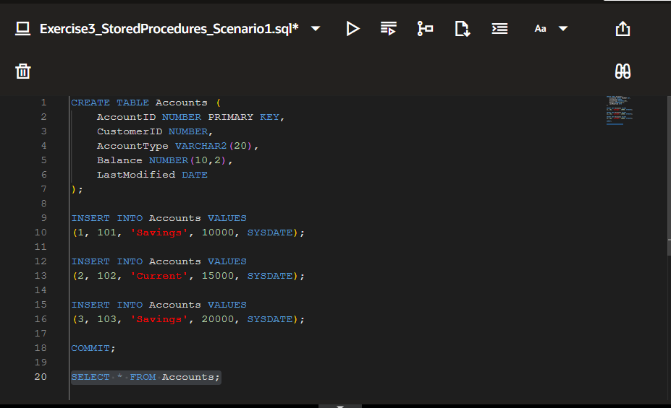
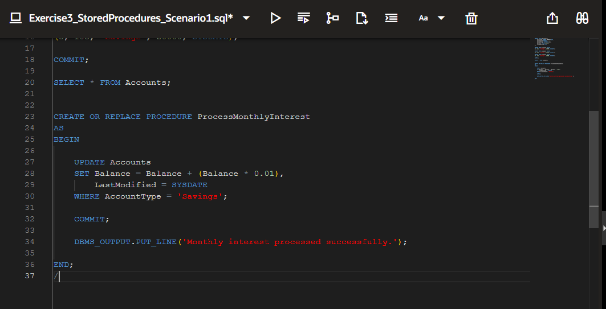

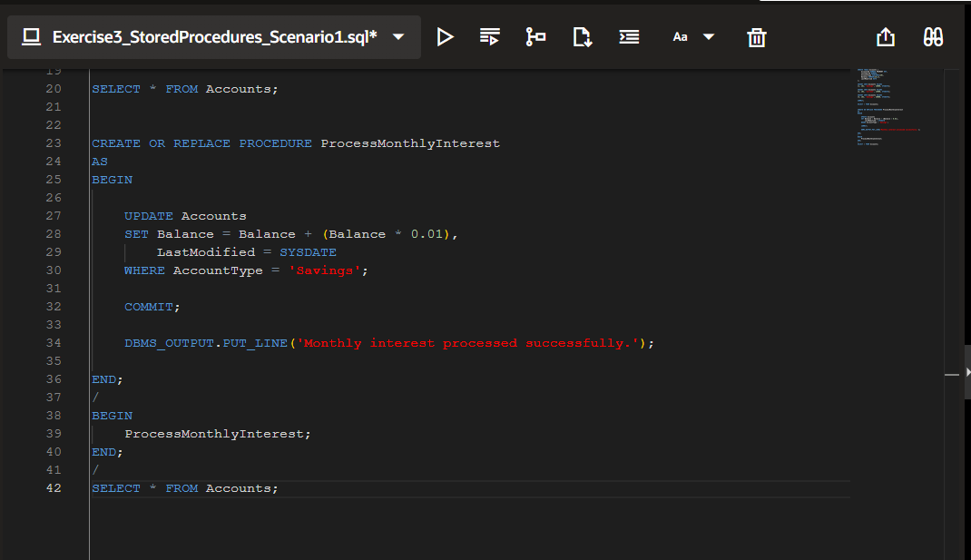
Output: 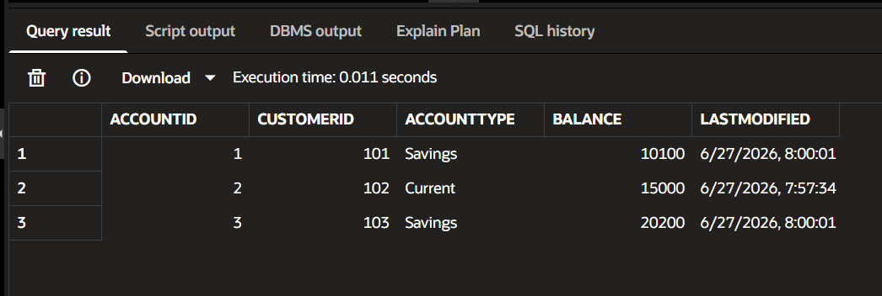
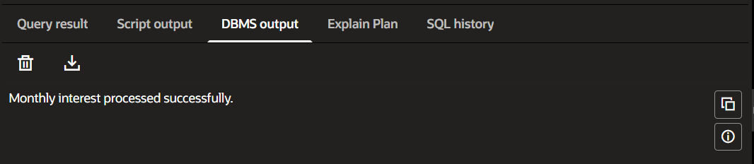

Scenario 2: Update Employee Bonus
Requirement: Update employee salaries by adding a bonus percentage for a specified department.
Logic Used: Create an Employees table, create the UpdateEmployeeBonus stored procedure, accept department name and bonus percentage as parameters, update eligible employee salaries, and commit the changes.
Expected Result: Employees in the selected department receive the specified bonus, while other departments remain unchanged.
Implementation:
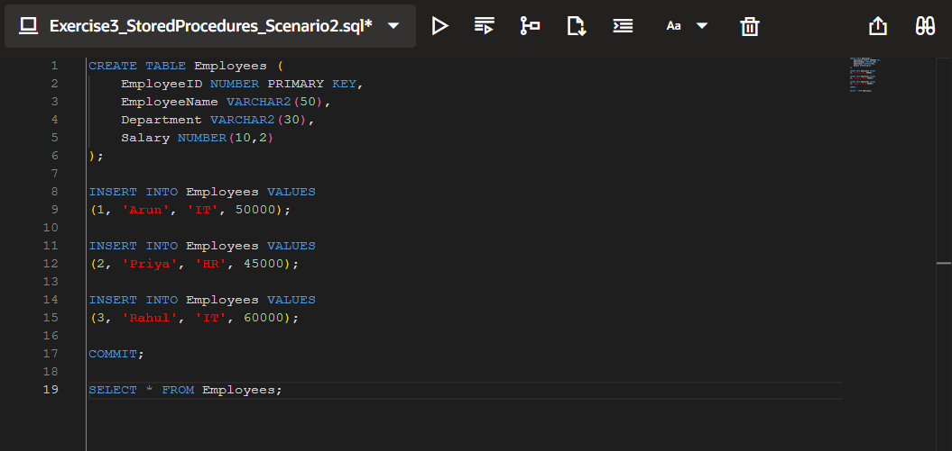
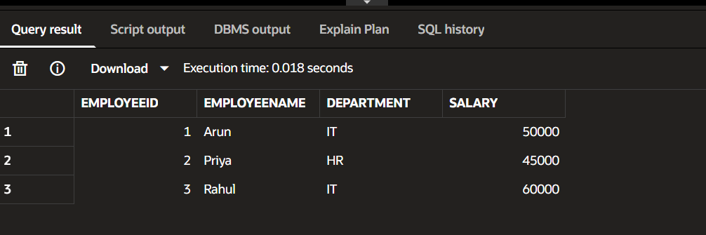

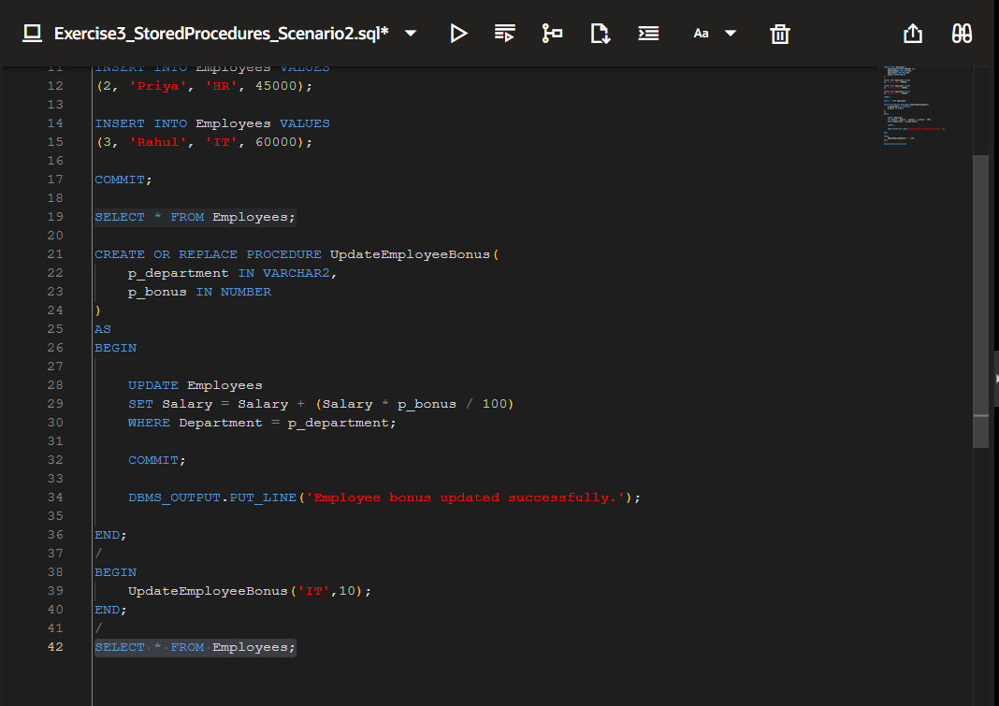
Output:
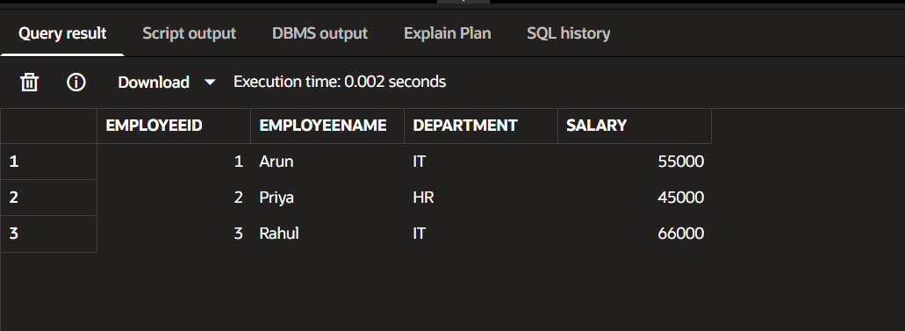
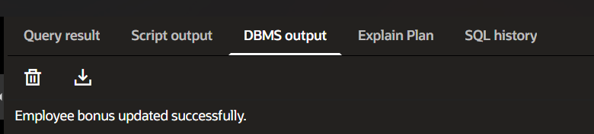

Scenario 3: Transfer Funds
Requirement: Transfer a specified amount from one account to another after checking sufficient balance.
Logic Used: Use the Accounts table, create the TransferFunds stored procedure, verify the source account balance, deduct the amount from the sender, add it to the receiver, commit the transaction, and display the status.
Expected Result: Funds are transferred successfully when sufficient balance exists; otherwise, no transfer is performed.
Implementation:
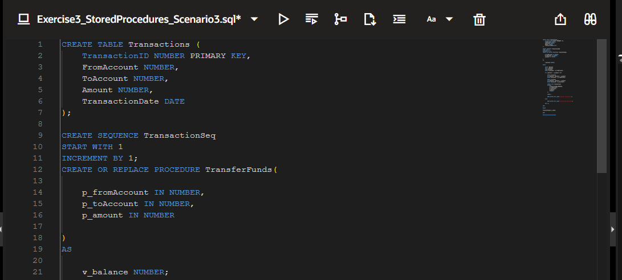
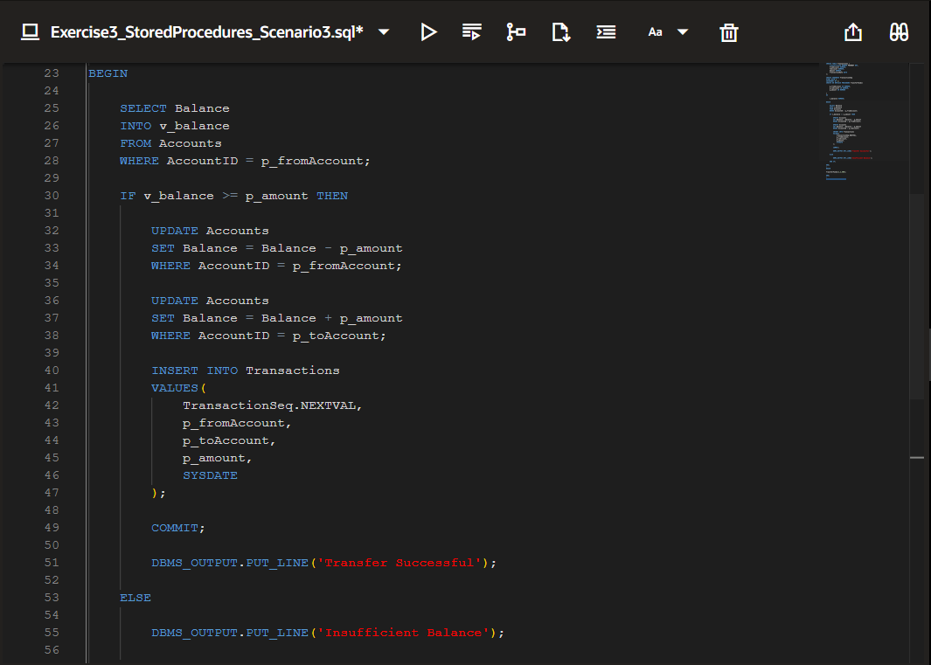
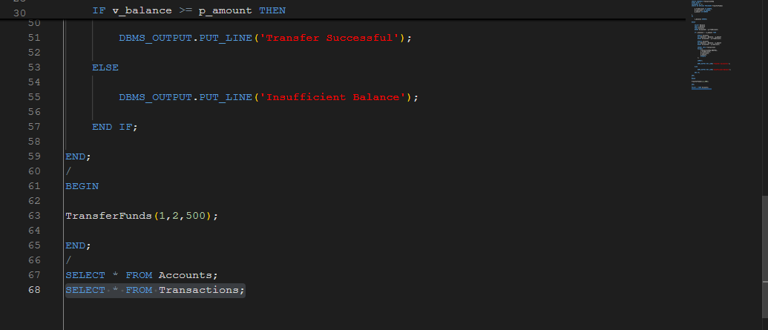

Output:
